24SDCS02 / 24SDCS02E / 24SDCS02P / 24SDCS02L – FSAD WORKBOOK
DEPARTMENT OF CSE, CS&IT, AI&DS
COURSE CODE: 24SDCS02 / 24SDCS02E / 24SDCS02P / 24SDCS02L
FULL STACK APPLICATION DEVELOPMENT Date of the Session: / / Time of The Session: to #SKILL - 2 ⎝ Hibernate CRUD Operations
Prerequisites:
• Basic knowledge of Java
• Understanding of classes, objects, and OOP
• Familiarity with SQL basics e product details such as productId, name, description, price, and quantity. The admin should be able to add new products, retrieve product information, update price or quantity, and delete discontinued products. Your task is to implement complete CRUD operations using Hibernate with proper entity mapping using JPA annotations.
1. Create a Product entity with fields: id (primary key), name, description, price, quantity.
2. Configure Hibernate and map the Product entity to a table using JPA annotations.
3. Insert multiple Product records into the database.
4. Retrieve a product using its id.
5. Update the price or quantity of any selected product.
6. Delete a product record by id if it is discontinued.
7. Note:
a. Implement Hibernate ID generation strategies (AUTO, IDENTITY, SEQUENCE) inside the entity to observe how primary key values differ.
b. The ID can be manual or auto generated, based on your chosen strategy.
8. Push the Hibernate project into a single GitHub repository.
Pom.xml
<project xmlns="http://maven.apache.org/POM/4.0.0"
xmlns:xsi="http://www.w3.org/2001/XMLSchema-instance"
xsi:schemaLocation="http://maven.apache.org/POM/4.0.0
http://maven.apache.org/xsd/maven-4.0.0.xsd">

<modelVersion>4.0.0</modelVersion>

<!-- Project Details -->
<groupId>com.retail</groupId>
<artifactId>inventory-system</artifactId>
<version>0.0.1-SNAPSHOT</version>
<packaging>jar</packaging>

<name>InventorySystem</name>

<!-- Java Version -->
<properties>
<maven.compiler.source>17</maven.compiler.source>
<maven.compiler.target>17</maven.compiler.target>
</properties>

<!-- Dependencies -->
<dependencies>

<!-- Hibernate Core -->
<dependency>
<groupId>org.hibernate.orm</groupId>
<artifactId>hibernate-core</artifactId>
<version>6.4.4.Final</version>
</dependency>

<!-- MySQL Driver -->
<dependency>
<groupId>com.mysql</groupId>
<artifactId>mysql-connector-j</artifactId>
<version>8.3.0</version>
</dependency>

<!-- JPA API -->
<dependency>
<groupId>jakarta.persistence</groupId>
<artifactId>jakarta.persistence-api</artifactId>
<version>3.1.0</version>
</dependency>

<!-- Logging -->
<dependency>
<groupId>org.slf4j</groupId>
<artifactId>slf4j-simple</artifactId>
<version>2.0.12</version>
</dependency>

</dependencies>

</project>
HibernateUtil.java
package com.retail.util;
import org.hibernate.SessionFactory;
import org.hibernate.cfg.Configuration;
public class HibernateUtil {
private static final SessionFactory sessionFactory;
static {
try {
sessionFactory = new Configuration()
.configure("hibernate.cfg.xml")
.buildSessionFactory();
} catch (Throwable ex) {
System.err.println("SessionFactory creation failed: " + ex);
throw new ExceptionInInitializerError(ex);
}
}
public static SessionFactory getSessionFactory() {
return sessionFactory;
}
public static void shutdown() {
getSessionFactory().close();
}
}
Product.java
package com.retail.entity;
import jakarta.persistence.*;
@Entity
@Table(name = "products")
public class Product {
@Id
@GeneratedValue(strategy = GenerationType.IDENTITY)
private Long id;
@Column(nullable = false)
private String name;
private String description;
private double price;
private int quantity;
public Product() {
}
public Product(String name, String description, double price, int quantity) {
this.name = name;
this.description = description;
this.price = price;
this.quantity = quantity;
}
public Long getId() {
return id;
}

public String getName() {
return name;
}

public void setName(String name) {
this.name = name;
}
public String getDescription() {
return description;
}

public void setDescription(String description) {
this.description = description;
}
public double getPrice() {
return price;
}

public void setPrice(double price) {
this.price = price;
}
public int getQuantity() {
return quantity;
}
public void setQuantity(int quantity) {
this.quantity = quantity;
}
}
MainApp.java
package com.retail;
import com.retail.entity.Product;
import com.retail.util.HibernateUtil;
import org.hibernate.Session;
import org.hibernate.Transaction;
public class MainApp {
public static void main(String[] args) {
insertProducts();
getProductById(1L);
updateProduct(1L, 95000, 20);
deleteProduct(2L);

HibernateUtil.shutdown();
}
public static void insertProducts() {
Session session = HibernateUtil.getSessionFactory().openSession();
Transaction tx = session.beginTransaction();

Product p1 = new Product("Laptop", "Gaming Laptop", 85000, 10);
Product p2 = new Product("Mobile", "Smartphone", 25000, 30);
Product p3 = new Product("Headphones", "Wireless Headphones", 3000, 50);

session.persist(p1);
session.persist(p2);
session.persist(p3);

tx.commit();
session.close();

System.out.println("Products Inserted Successfully");
}
public static void getProductById(Long id) {
Session session = HibernateUtil.getSessionFactory().openSession
Product product = session.get(Product.class, id);

if (product != null) {
System.out.println("Product Found:");
System.out.println("Name: " + product.getName());
System.out.println("Price: " + product.getPrice());
System.out.println("Quantity: " + product.getQuantity());
} else {
System.out.println("Product Not Found");
}

session.close();
}
public static void updateProduct(Long id, double newPrice, int newQuantity) {
Session session = HibernateUtil.getSessionFactory().openSession();
Transaction tx = session.beginTransaction();
Product product = session.get(Product.class, id);
if (product != null) {
product.setPrice(newPrice);
product.setQuantity(newQuantity);
session.merge(product);
System.out.println("Product Updated Successfully");
} else {
System.out.println("Product Not Found for Update");
}

tx.commit();
session.close();
}
public static void deleteProduct(Long id) {
Session session = HibernateUtil.getSessionFactory().openSession();
Transaction tx = session.beginTransaction();
Product product = session.get(Product.class, id);
if (product != null) {
session.remove(product);
System.out.println("Product Deleted Successfully");
} else {
System.out.println("Product Not Found for Deletion");
}
tx.commit();
session.close();
}
}

Structure:
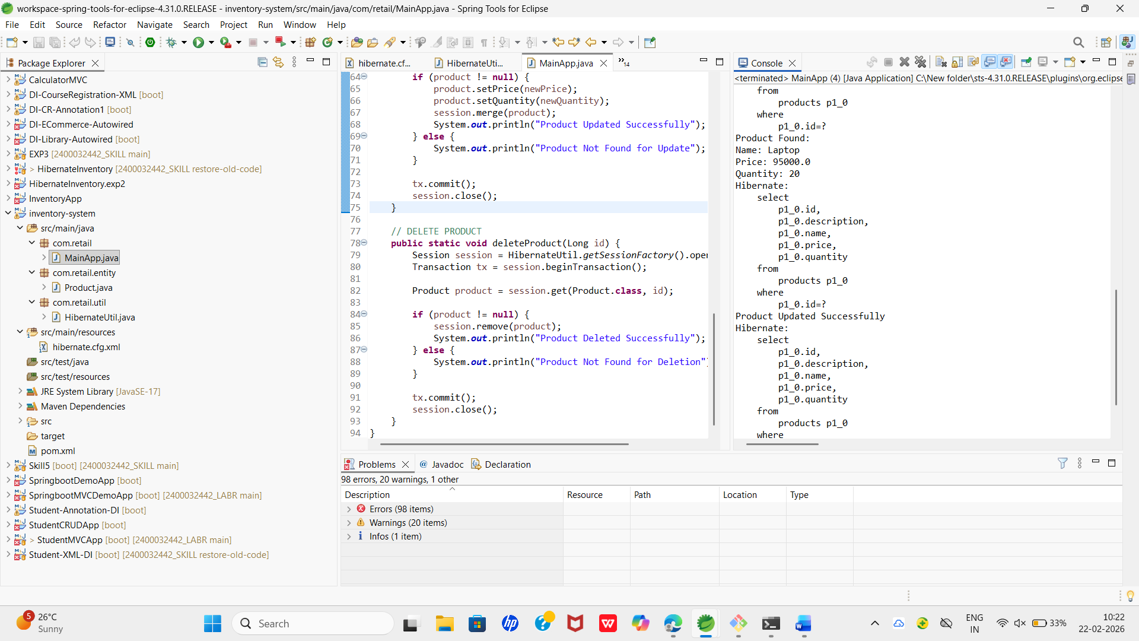

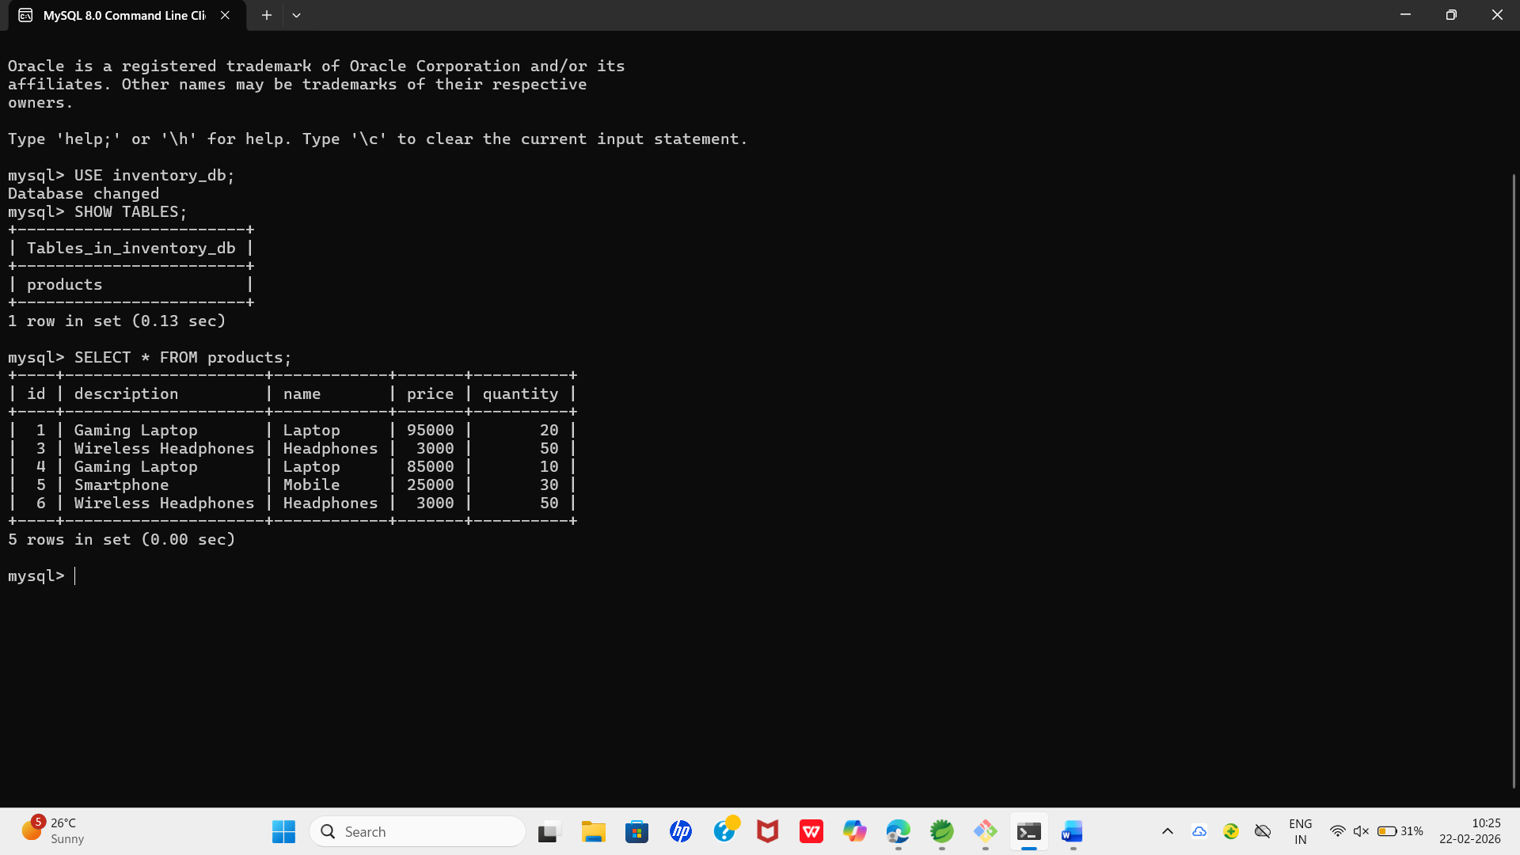
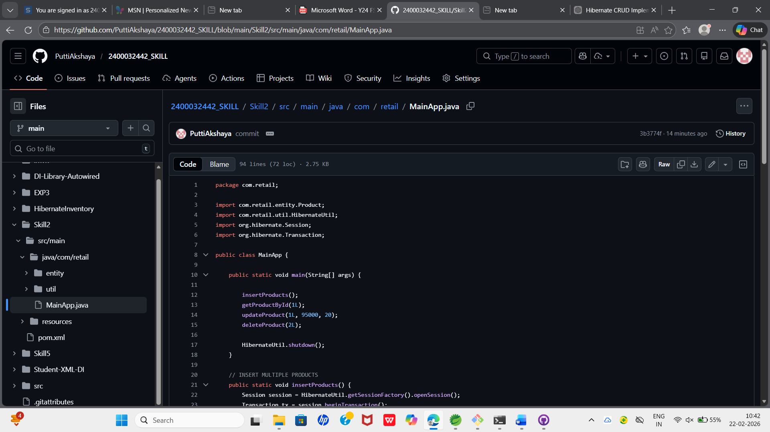

VIVA QUESTIONS:

1. What is ORM and why is it used?
ORM (Object Relational Mapping) is a technique that maps Java objects to database tables. It is used to simplify database operations, reduce SQL code, and improve development efficiency.

2.Which annotation marks a class as a JPA entity?
@Entity

3.Why must every Hibernate entity have a primary key?
Because Hibernate needs a primary key to uniquely identify, update, delete, and manage each record.

4.How do you update an existing record using Hibernate?
Retrieve the object using its ID, modify its fields, and commit the transaction.

5.Difference between get() and load() in Hibernate?
get() returns null if the record does not exist, while load() throws an exception if the record is not found.

